**Experiment No. 2.1**

**Student Name: Rishav Kumar UID: 22MCC20039**

**Branch: MCA - CCD Section/Group: MCD-1/ Grp A**

**Semester: IV Date of Performance: 15th Mar 24**

**Subject Name: Big Data Analytics Subject Code: 22CAP-782**

1. **Aim/Overview of the practical:**

Word Count Map Reduce program to understand Map Reduce Paradigm

1. **Code for practical:**

* Open terminal in Ubuntu and create a wordcount.java file.
* Add map reduce code in java file.
* Make a directory and put an input.txt file in it using

***hdfs dfs -put /wordcount/input.txt /wordcount/Input***

* Make class files using command

***javac -classpath ${HADOOP_CLASSPATH} -d '/home/hadoop/wordCount/files' '/home/hadoop/wordCount/WordCount.java'***

* Make jar from class files

***jar -cvf wordCount.jar -C files/ .***

* Run Jar file to run map reduce program

***hadoop jar /home/hadoop/wordCount/wordCount.jar WordCount /wordCount/Input /wordCount/Output***

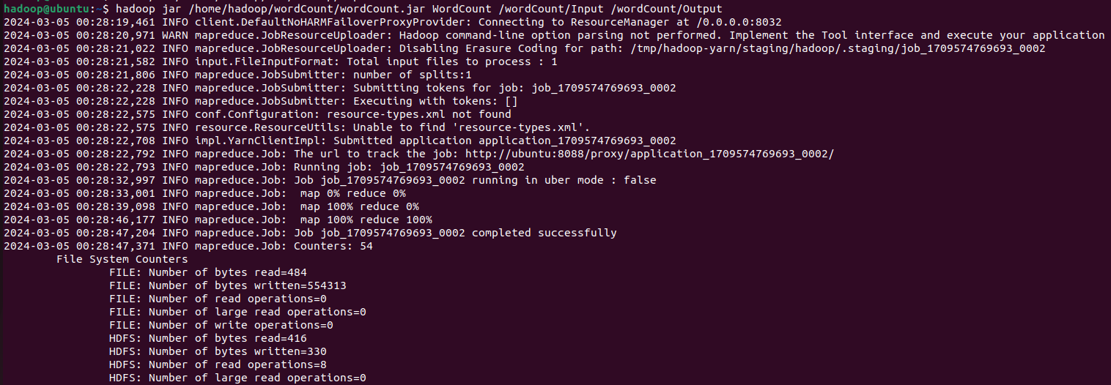

* View output using command:

***hdfs dfs -cat /wordcount/Output/\****

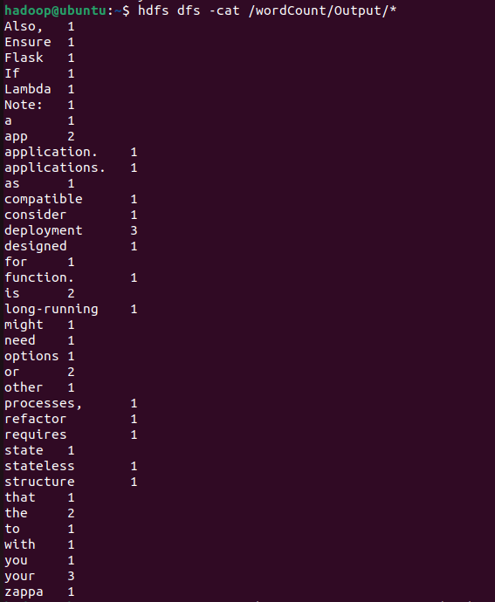

**************************************** **THE END** ***********************************************